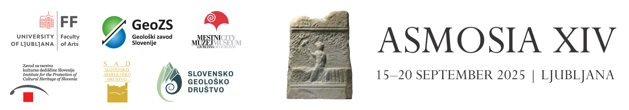

**Abstract submission form**

**to be submitted as a WORD file to** [**asmosia14@arnes.si**](mailto:asmosia14@arnes.si) **by 15th January 2025**

|  |  |
| --- | --- |
| **TITLE**  Times New Roman 14 pt, aligned left, bold, only capital letters |  |

|  |  |
| --- | --- |
| First Author1  Times New Roman 12 pt, aligned left |  |
| Second Author2 |  |
| Third Author3 |  |
| Fourth Author4 |  |
| Fifth Author5 |  |
| Sixth Author6 |  |

|  |  |
| --- | --- |
| 1 Affiliation of the first author, including Department/Institution, City, Country, email address  Times New Roman 12 pt, aligned left |  |
| 2 Affiliation of the second author, including Department/Institution, City, Country, email address |  |
| 3 Affiliation of the third author, including Department/Institution, City, Country, email address |  |
| 4 Affiliation of the fourth author, including Department/Institution, City, Country, email address |  |
| 5 Affiliation of the fifth author, including Department/Institution, City, Country, email address |  |
| 6 Affiliation of the sixth author, including Department/Institution, City, Country, email address |  |
|  | E.g.:  University of Ljubljana, Faculty of Arts, Department of Archaeology, Ljubljana, Slovenia, Katharina.Zanier@ff.uni-lj.si |

|  |  |
| --- | --- |
| **Three keywords**  Times New Roman 12 pt, aligned left |  |

|  |  |
| --- | --- |
| **Abstract**  Guidelines  Abstracts have to be prepared in English. The text should be between 200-400 words. Abstracts should be a condensed version of your presentation (oral or poster) and include all significant findings. The text should include a brief introduction and motivation of the study, including experimental procedures, main results and conclusions. Use italics for taxonomic terms. Do not indent paragraphs.  Please note  Members of the EC or other experts called for this purpose will review the abstracts to determine if they conform to the subjects of the conference and if they can be accepted for presentation. The reviewers will also determine if the paper is for oral or poster presentation. One oral presentation per participant is allowed.  Times New Roman 12 pt, justified on both sides, single spacing between lines |  |

Session to which the abstract is submitted:

Applications to Specific Archaeological Questions – Use of Marble.

Provenance Identification I: (Marble).

Provenance Identification II: (Other Stones).

Advances in Provenance Techniques, Methodologies and Databases.

Quarries and Geology: (Quarrying Techniques, Organization, Transport of Stones, New Quarries, Stone Carving and Dressing, Hazards to and Preservation of Quarries).

Stone Properties, Weathering Effects and Restoration, as related to diagnosis problems, matching of stone fragments and authenticity.

Pigments and Paintings on Marble.

Limestones and other rocks of the Alpine-Dinaric-Pannonian area: sources, extraction and use

Preference for oral or poster presentation (please note the oral preference does not oblige the reviewers; one oral presentation per participant is allowed):

Oral presentation

Poster presentation

Student best poster competition:

Yes

No

TERMS AND CONDITIONS

The applicants of the paper confirm that they are the authors of the submitted abstract, which, if it is accepted, will be published in the Book of Abstracts of the 14th International Conference of the Association for the Study of Marble and Other Stones in Antiquity, published by the Ljubljana University Press, Faculty of Arts, Aškerčeva 2, 1000 Ljubljana, Slovenia, with indication of the authorship by mention of the name and surname, affiliation and e-mail address.

PROTECTION OF PERSONAL DATA

The Faculty of Arts of the University of Ljubljana, Aškerčeva cesta 2, 1000 Ljubljana, will process your personal data for the preparation of the above-mentioned Book of Abstracts and communications related to it (the legal basis is the execution of the contract, Article 6/1(b) GDPR). Data will be kept for five years after the end of the conference, and permanently in case of publication in the Book of Abstracts. If you do not want to provide us with your personal data, you will not be able to apply for participation at the conference with a paper. Personal data will also be accessed by website maintenance company Enki, d.o.o., Tehnološki park 19, 1000 Ljubljana, Slovenia.

We inform you that you can exercise the right to access your personal data, the right to correction, the right to deletion, the right to limit processing and the right to data portability at any time. For questions regarding the protection of personal data, you can contact the authorized person for data protection of the University of Ljubljana at the e-mail address dpo@uni-lj.si. If you think that we are not exercising your rights properly, you can complain to the Information Commissioner of the Republic of Slovenia (ip-rs.si).

By submitting the abstract submission form, you accept the conditions of participation, and you allow the Faculty of Arts of the University of Ljubljana to process your personal data for the purpose of preparing and publishing the conference proceedings.